|  |  |  |  |  |  |
| --- | --- | --- | --- | --- | --- |
| Date | December 13,2022 | | | Tester Name | Syed Shahabuddin |
| Environment | Penfax - Test | | | Login used |  |
| Operating System | Windows | Version: | Update: | | |
| Software Used | Edge | Version: | Update: | | |
| Select Software | Version: | Update: | | |
| Release version | 22.4.1 | | | | |
| Title | E23.09 | | | | |
| Test Type | Regression | | | | |
| Test Scenario | Member Withdrawal Letters (PEPP and VPB) | | | | |
|  |  | | | | |
| Expected Results | Verify the batch run successfully and letters generated and saved on member communications  Some payments that should be used during this test to ensure letters printed are:  - Termination payment (to cash, RRSP, LIRA)  - Retirement payment (to LIRA, pRRIF, Outside Annuity, LIF, LRIF, RRIF) | | | | |
| Pass/Fail | Pass | | | JIRA# | N/A |

|  |  |  |  |
| --- | --- | --- | --- |
| Stakeholder | Type of payment | Retire/term (over 50/under) | Batch and letters successful |
| 258661 | Cash | Term | checked |
| 302728 | LIRA (2 FI’s) | Retire | checked |
| 258669 | Cash (partial) | Retire | checked |
| 280602 | RRSP | Term | checked |
| 128467 | SRB to spouse | SRB (added SIN & address to spouse) | checked |
| 341242 (299191) | Death to spouse (cash) | Spouse USA resident (added SIN) | (letter in non-mbr batch) |
| 253278 | Vpb lump sum | VPB NET pmt | checked |
| 258664 | VPB to outside annuity | 200k gross | checked |

Other letters for Syed in batch.

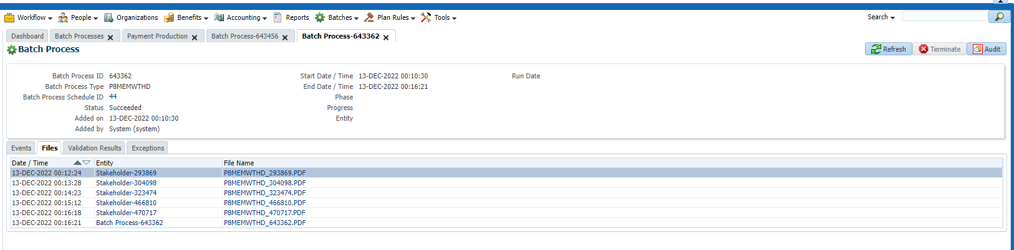

All letters generated correctly & open.

All letters appear in the batch process letter file.

Both PEPP and VPb included.

